INPUT/OUTPUT AND ERROR HANDLING

EC 5080

SOFTWARE CONSTRUCTION

WIJAYAWARDHANA W.A.H.A.

2019/E/166

SEMESTER 05

16 SEPTEMBER 2022

QUESTION 01

PART 01

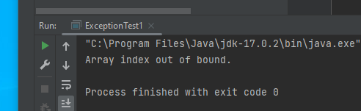

FIGURE 01 – ArrayIndexOutOfBoundsException OUTPUT

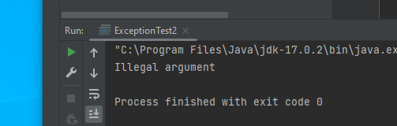

FIGURE 02 – IllegalArgumentException OUTPUT

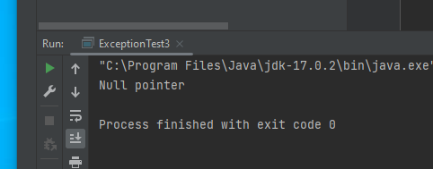

FIGURE 03 – NullPointerException OUTPUT